**Iwt**

August 21 2021

**Contents**

1. Page 1
2. Page 2

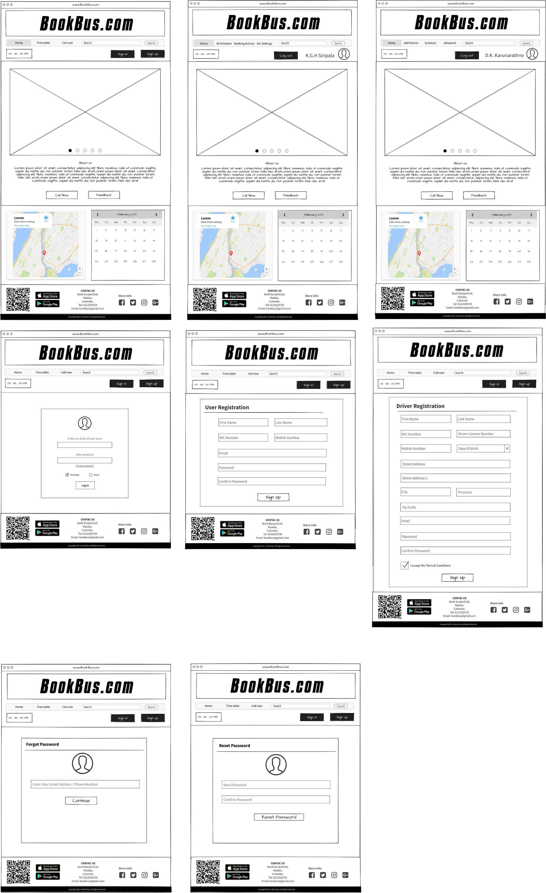

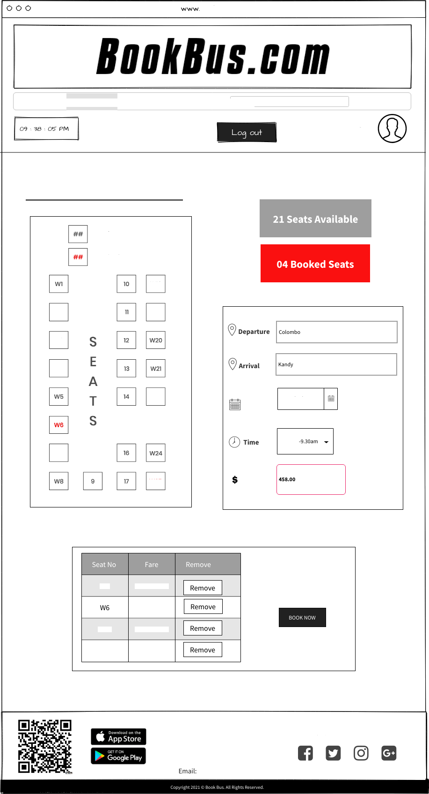

Home All Schedule Booking Activity Acc Settings

Search

K.G.H Siripala

Booking Details

Avoiloble seats

Booked Seats

W2

W\9

W3

W4

W22

Date

2021’10 ’24

6.30a m

W7

W25

W2

LKR 458.00

Seats: 04

Sub Total: LKR 1832.00

LKR 458.00

W19

LKR 458.00

W2S

LKR 458.00

CONTAC US

BooL Bustpvt) Ltd, Malabe, Colombo.

Tel: 0112529729

[booLbus@gmail.com](mailto:booLbus@gmail.com)

More info

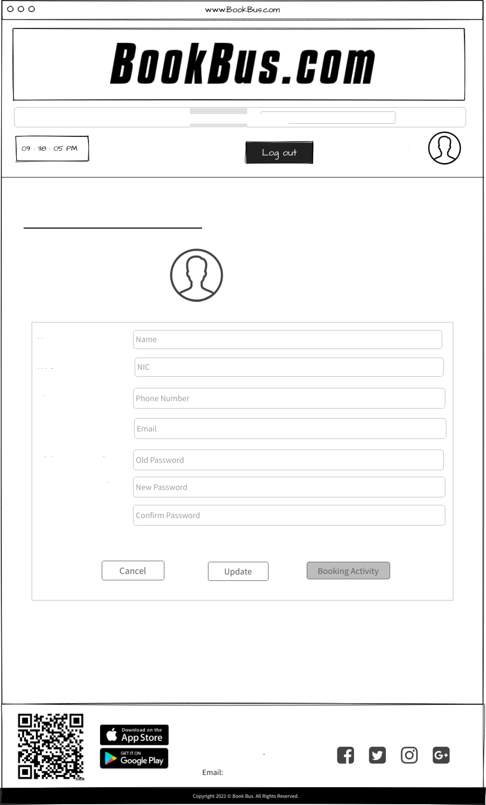

Home All Schedule Booking Activity Acc Settings Search

K.G.H Siripala

User Account Sewings

Username

User ID: 12365

Hame

hIIC

Phone

E-mail

Oid Password Hew Password

Confirm Password

CONTAC US

Book Bustpvt) Ltd, Malabe, Colom bo

Tel: 0112529729

[bookbus@gmail.com](mailto:bookbus@gmail.com)

More info

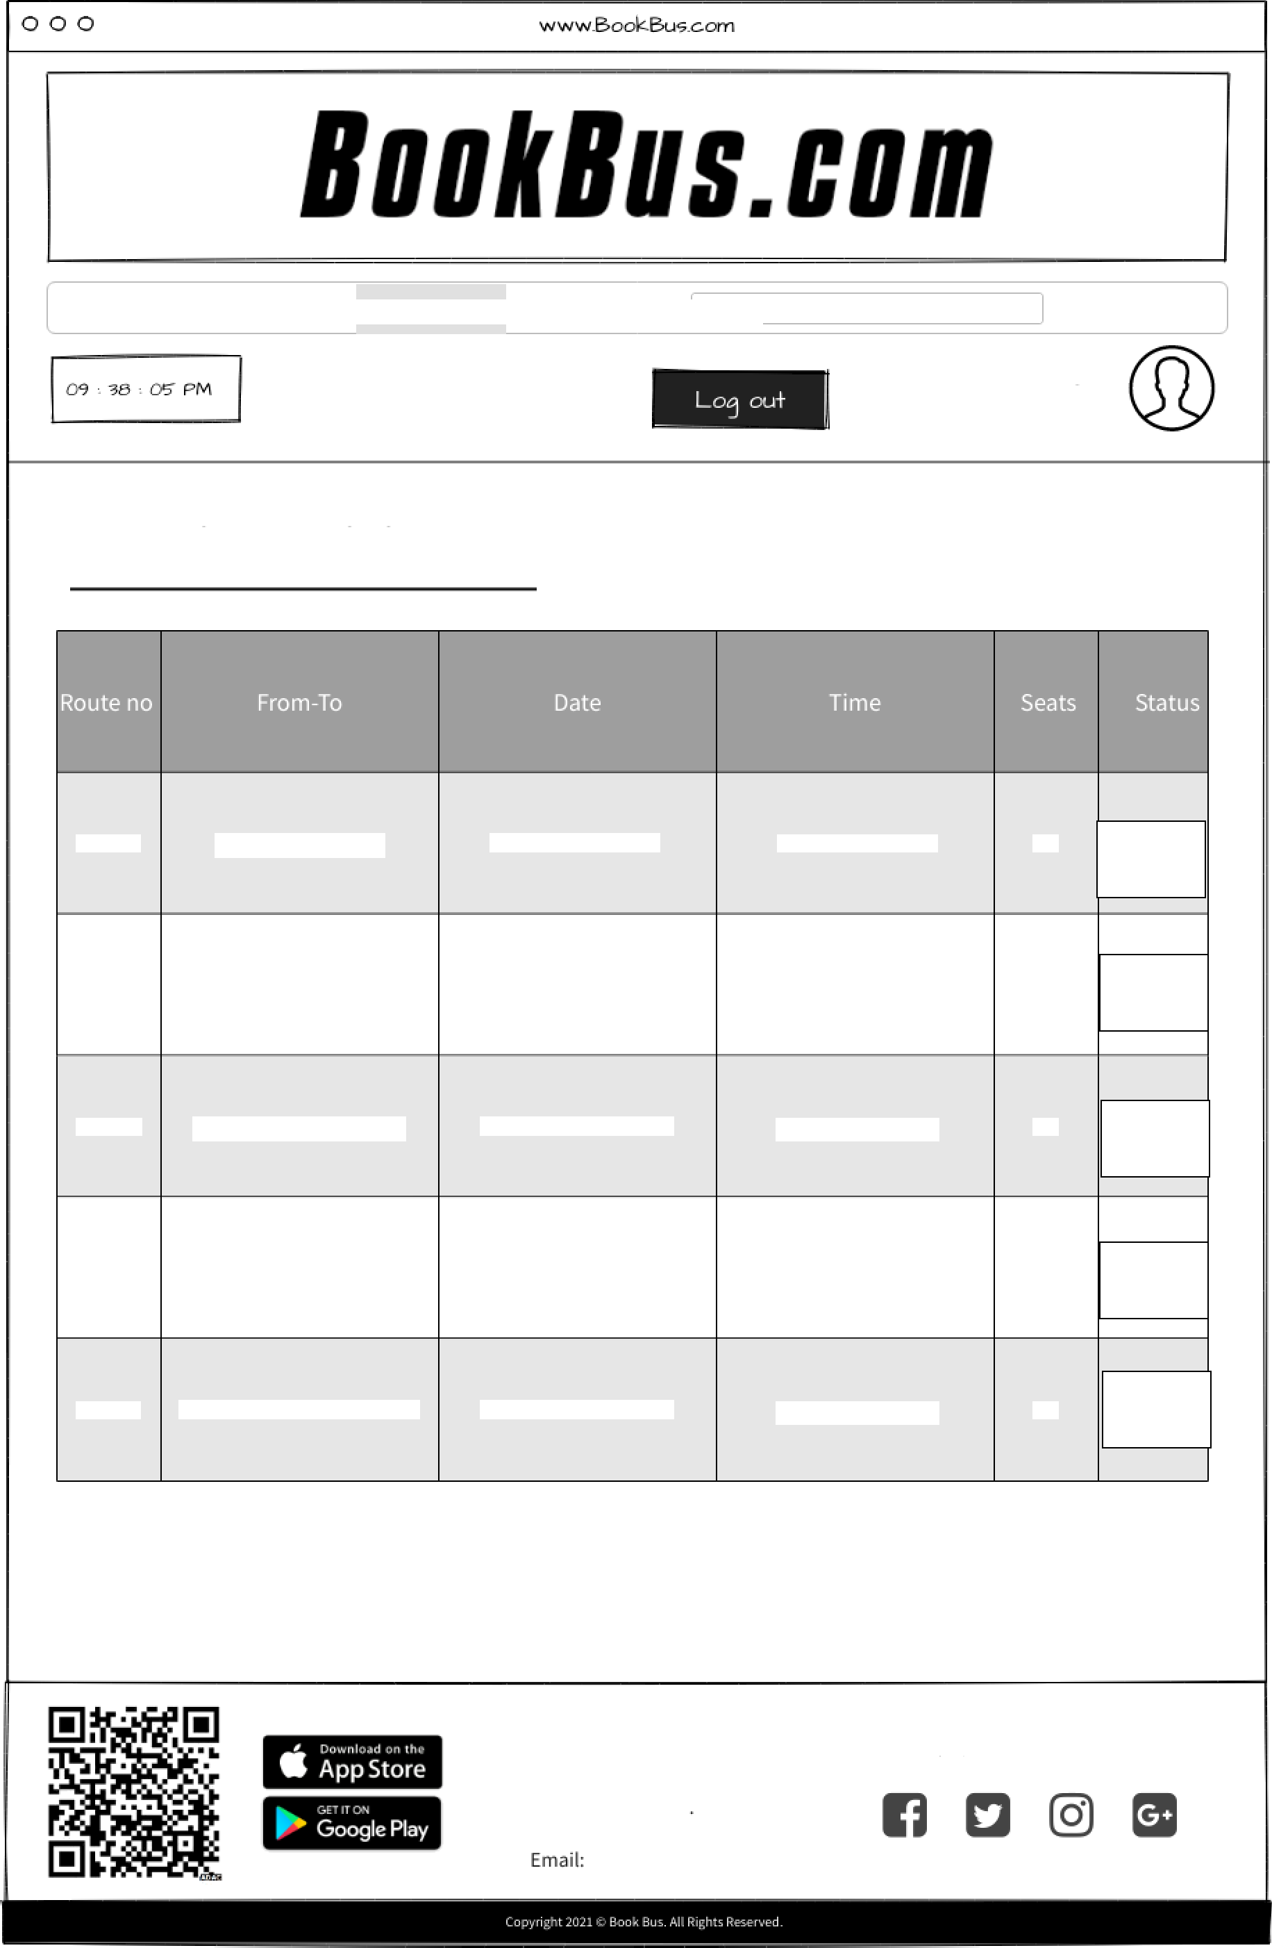

Home All Schedule Booking Activity Acc Settings

Search

K.G.H Siripala

Booking Activity

AA001

Colombo-Kandy

2021 October 24

6.30am-9.30am

02

Cancel

AA002

Colombo—Galle

2021 September 27

7.00am-8.30am

05

Cancel

AA004

Colombo-Ratnapura

2021 November 16

1.30pm-4.25pm

0‘

Cancel

AA031 Colombo-Anuradhapura

2021 December 02

7.00am—1.00pm

05

Cancel

AA009 Colombo-Band arawela

2021 November 01

1.30pm-7.25pm

02

Cancel

CONTAC US

Book Bustpvt) Ltd, Malabe, Colom bo

Tel: 0112529729

[bookbus@gmail.com](mailto:bookbus@gmail.com)

More info

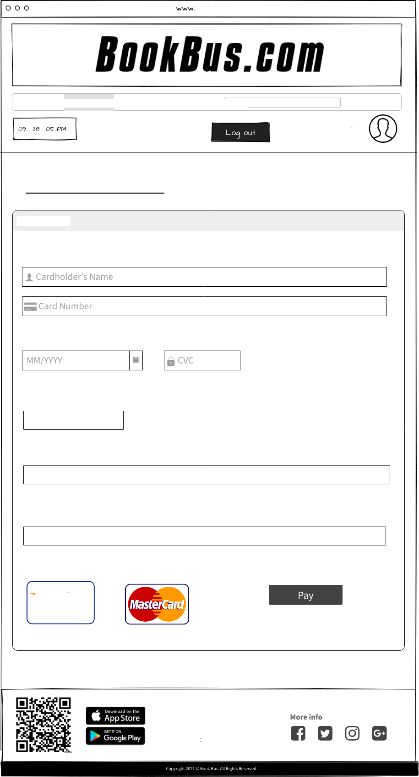

Home All Schedule Booking Activity Acc Settings Search

K.G.H Siripala

Payment Details

Visa/Master

Expiry

0128-bitsecured

Amount

RS.

Email

Moblie Phone Number

CONTAC US

BooL Busy pvt) Ltd,

Malabe,

C olombo.

Tel 0112529729

[Email: booLbus@gmail.com](mailto:booLbus@gmail.com)

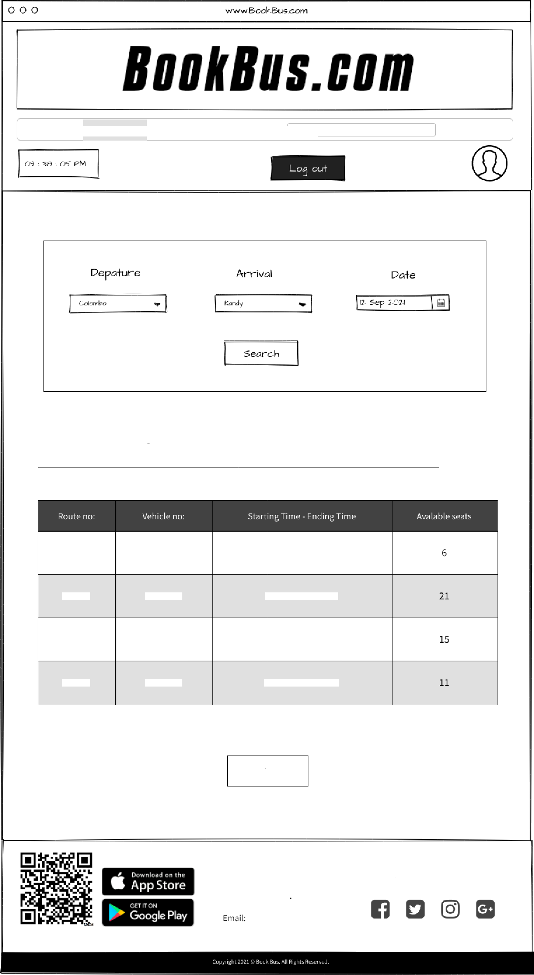

Home All Schedule Booking Activity Acc Settings Search

K.G.H Siripala

Bus schedule for Colombo to Kandy on 12 Sep 2021

Baok Now

CONTAC US

Book Bustpvt) Ltd, Malabe, Colom bo

Tel: 0112529729

[bookbus@gmail.com](mailto:bookbus@gmail.com)

More info

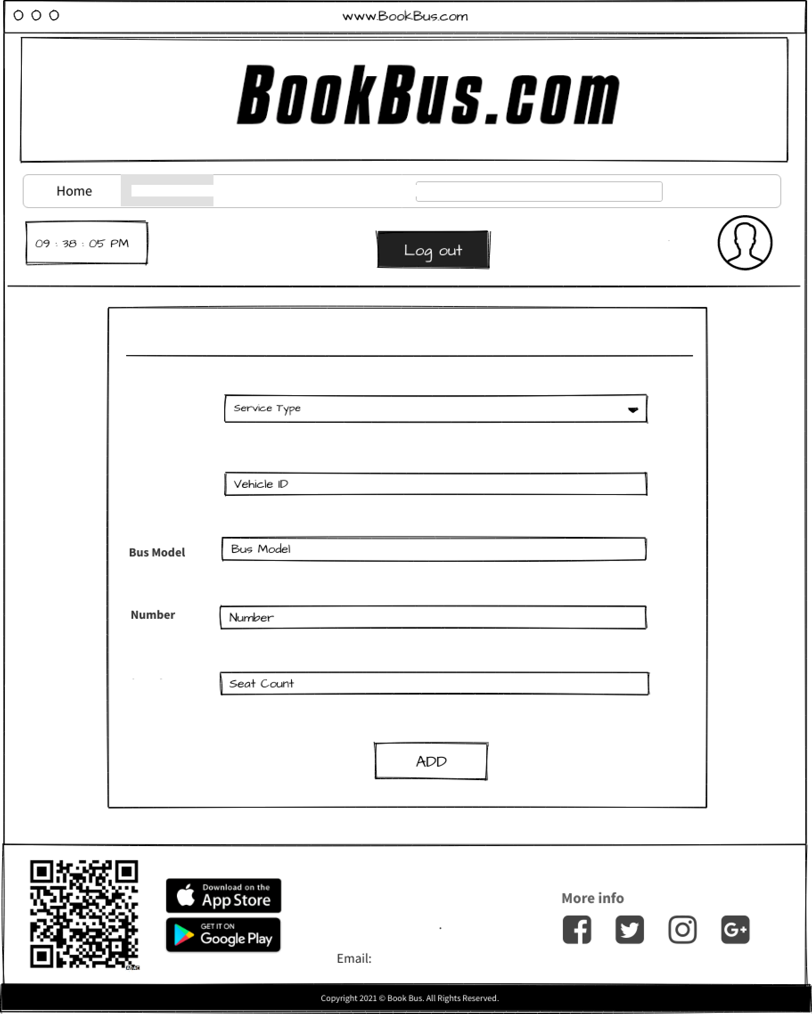

Add Vehicle Schedule Advanced

Search

D.K. Karunarathne

ADD VEHICLE

Service Type

Vehicle I D

Seat Count

CONTAC US

Book Bustpvt) Ltd, Malabe, Colom bo

Tel: 0112529729

[bookbus@gmail.com](mailto:bookbus@gmail.com)

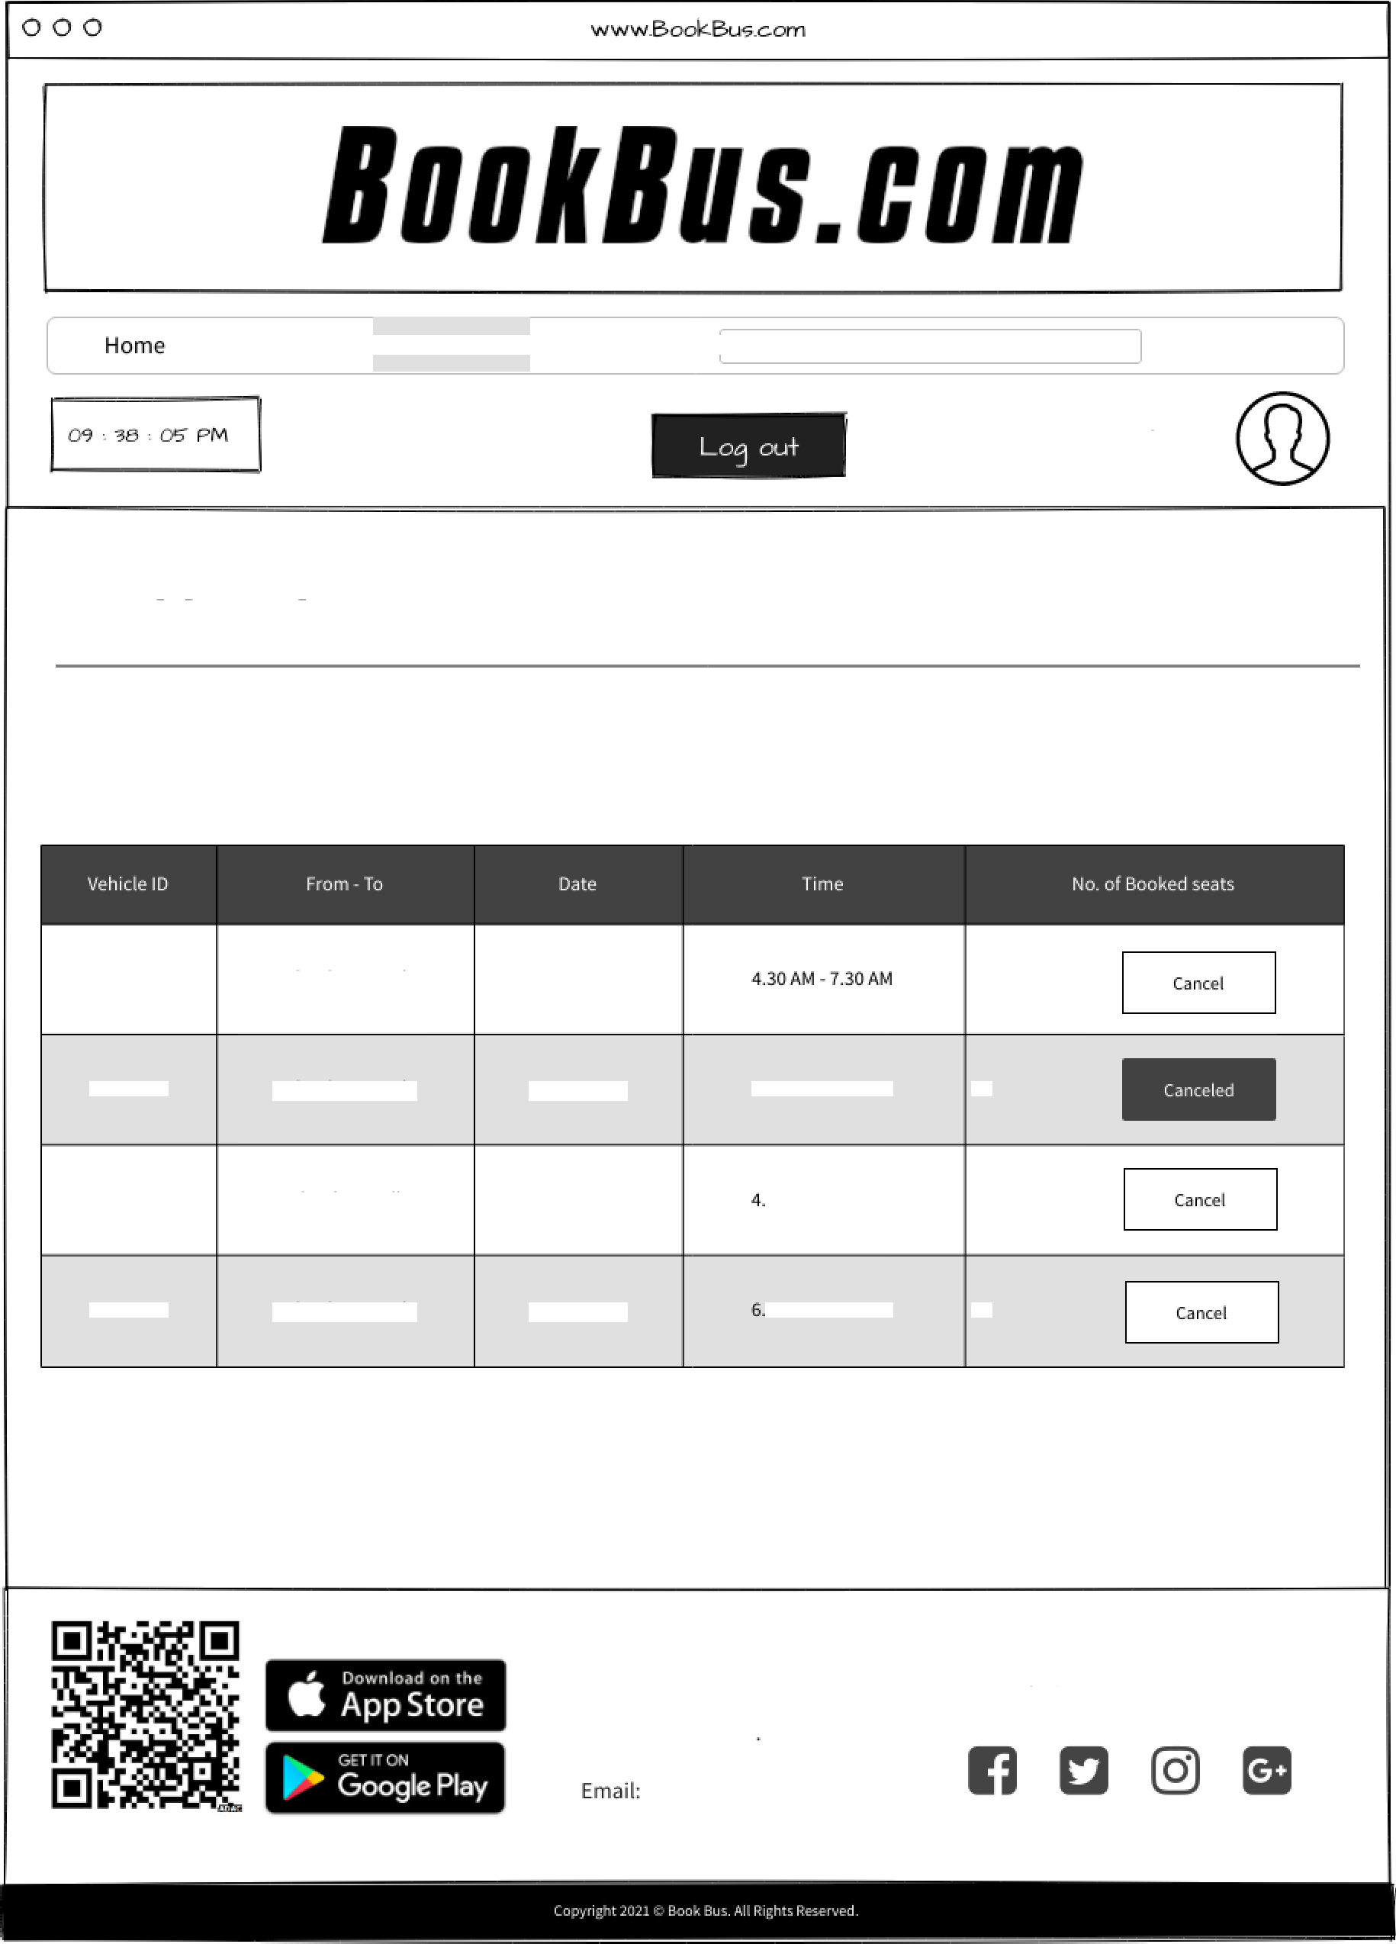

Add Vehicle Schedule Advanced

Search

D.K. Karunarathne

Dashboard

NO - 7278

Colombo - Kandy

12Sep3031

40

ND - 7278

Colombo - Kandy

l3Sep202l

6.30AN - 9.30AN 2i

NC-4816

Colombo - Galle

15Sep3031

00 PM - 7 00 PM 46

Malabe,

Colom bo Tel: 0112529729

[bookbus@gmail.com](mailto:bookbus@gmail.com)

More info

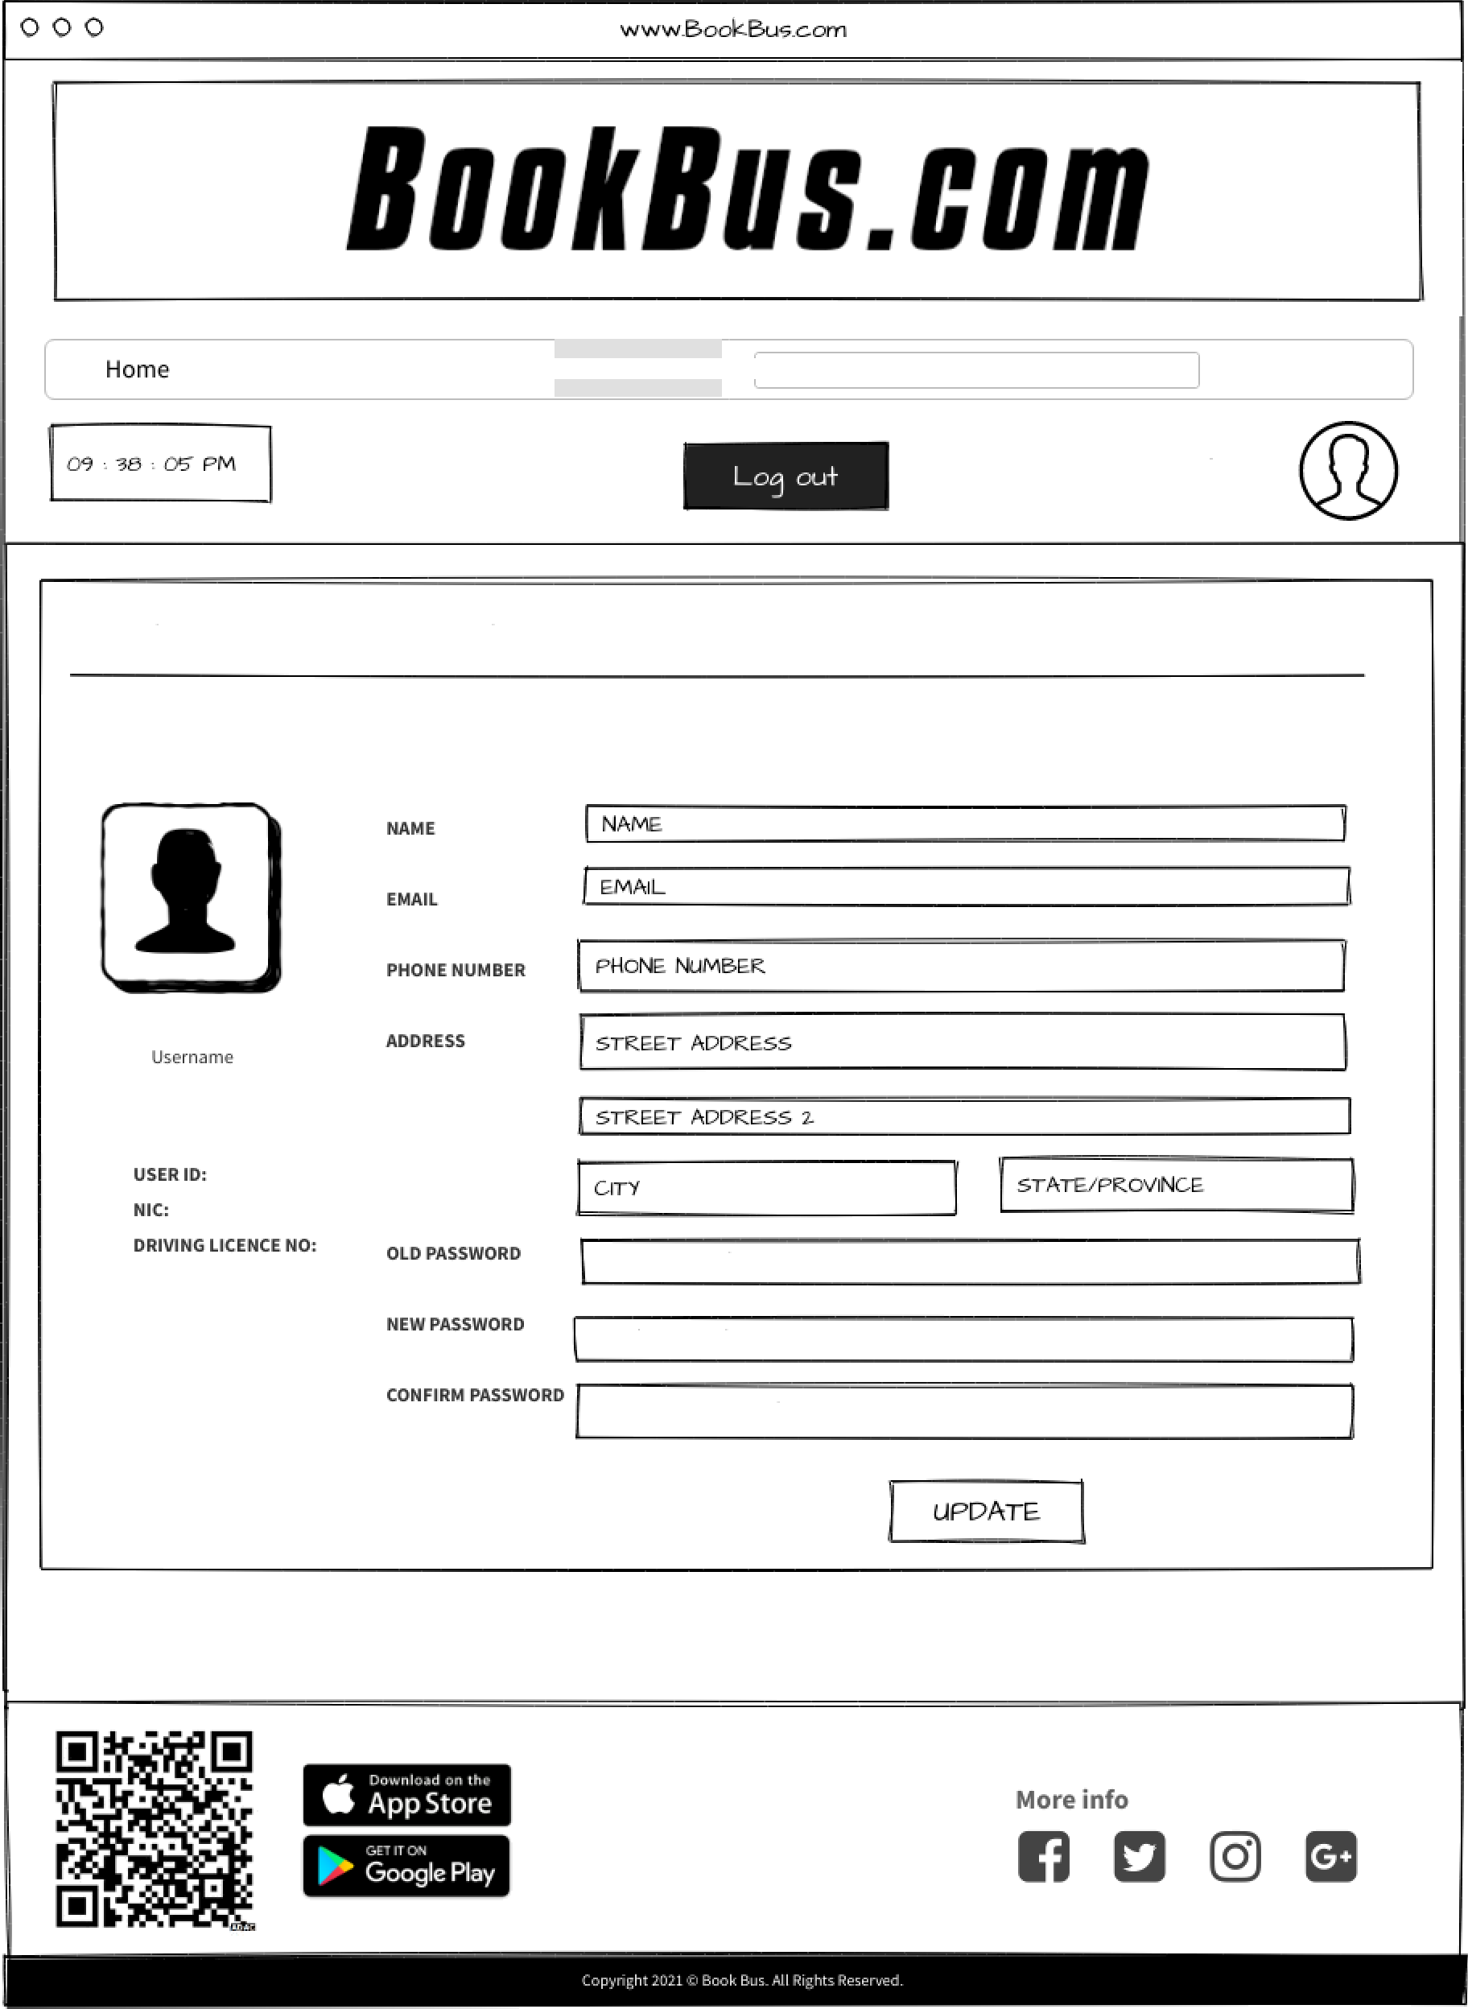

Add Vehicle Schedule Advanced

Search

D.K. Karunarathne

Driver Account Settings

Co spany NAfd E

OLD 9AssWOR&

NEW P'AssWOR& CoNVIRf \ P'AssWORD

CONTAC US

Book Bus(pvt) Ltd, M alabe, Colombo.

Tel: 0112529729

[Email: bookbus@gmail.com](mailto:bookbus@gmail.com)

|  |  |  |  |  |  |  |
| --- | --- | --- | --- | --- | --- | --- |
| AA001 | ND—7278 | 4.20 AM — 7.30AM | ND - 7278 | Colombo - Kandy | l8Sep202l | O0PN-9.00PM 32 |
| AA001 | ND—8536 | 6.20 AM — 9.30AM |  |  |  |  |
| AA001  AA001 | NC-4578  ND—6920 | 4.00 PITI - 7.00 PITI  6.00 PN - 9.00 PN |  |  | Bo | CONTAC US  ok Bustpvt) Ltd, |